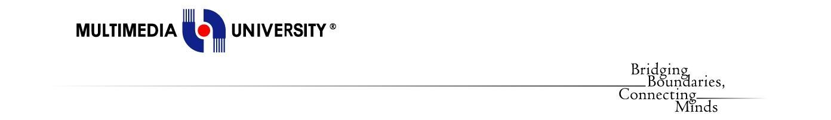

PROJECT TITLE:

Volunteering Management Platform

Web Application Development

**Developer: Shaaban, Mohammed Najib Ahmed**

CONTENTS

1. Introduction 3
2. Problem Statement 3
3. Objective 3
4. Task Division 4
5. Analysis:
   * Use Case Diagram 5
   * Requirement 6
6. Design
   * Placements of elements on page 7
   * Navigation Flow 7-8
   * Intuitive Design 8
7. Implementation
   * Screenshots & Description of Homepage 9
   * Plan for Assignment 2 10
8. Test Case 11
9. Conclusion 12

**Introduction**

In the world of non-profit organizations, volunteering is the essence in keeping an event going and success. Usually, volunteers help in day-to-day operations, and behind the scenes of the events. This means, the bigger the size of the events, the higher the number of volunteers involved. Thus, having a good volunteer management platform is a must to ensure the smoothness of the events. A good volunteer management platform starts from the process of recruiting volunteers until managing work division of the volunteer.

Furthermore, the volunteering platform also could be a platform for donor engagements. Having donor for the events also ensure the organizer continuity in surviving in this expensive world. For this activity, having a proper platform would increase society confidence towards the organizer. This donor system is different from sponsoring events. An events sponsors would expect at least exposure of the company towards public while donors’ concepts, allows those who wish to help and support in a way of their capabilities, as the donation may come in a small amount.

Every semester, MMU students engage in creating and managing events for the clubs and society. Most of the events run on a limited amount of resources, especially money. Thus, outsourcing committee is out of context and volunteering seems to be the best option. However, spreading the announcements of participation and collecting volunteer data are hard. Thus, this volunteering website comes in to ease MMU students works in finding for volunteer.

**Solution Analysis :**

**Use Case Diagram**

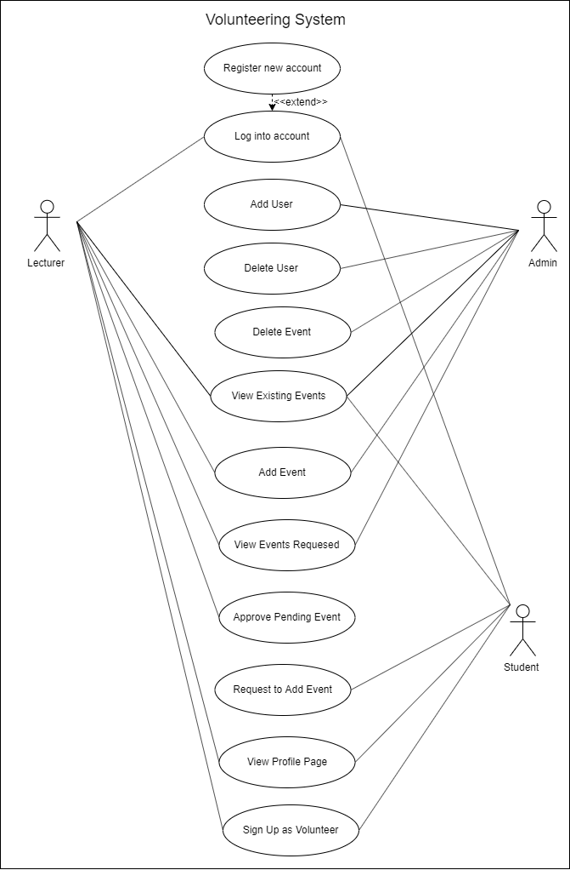

**User Requirements**

**Functional Requirements:**

**Admin:**

1. Admin can view events requested.
2. Admin can view existing events.
3. Admin can add/delete events.
4. Admin can add/delete users

**Lecturer:**

1. Lecturers can register a new account.
2. Lecturers can log in to account.
3. Admin can view events requested.
4. Lecturers can view existing events.
5. Lecturers can add event.
6. Lecturers can approved pending event
7. Lecturer can view profile page.
8. Lecturer can sign up as volunteer.

**Student:**

1. Students can register a new account.
2. Students can log in to account.
3. Students can request to add event.
4. Students can view existing events.
5. Students can sign up as a volunteer.
6. Students can view profile page.

**Non-Functional Requirements:**

1. Data saved in the database for easier recovery.
2. System has a login page for security purposes.
3. System follows the user’s time zone for time-tracking.
4. System will be updated according to the browsers update.

**Quality Requirements:**

1. Security
   * Only system admin can access the user data.
2. Reliability
   * Data saved into cache if there is no internet connection.
3. Availability

* System online 24/7 unless stated in the news for maintenance.
  + Users should be able to carry out an intended functionality with less than 5 navigations from home page.

1. Performance
   * Stable server to ensure fast data flow.
   * Navigation from a page to another should take at most 5 seconds.
2. Maintainability
   * System oversees by administrator 24/7

**Design Solution**

**Placements of Elements on Page**

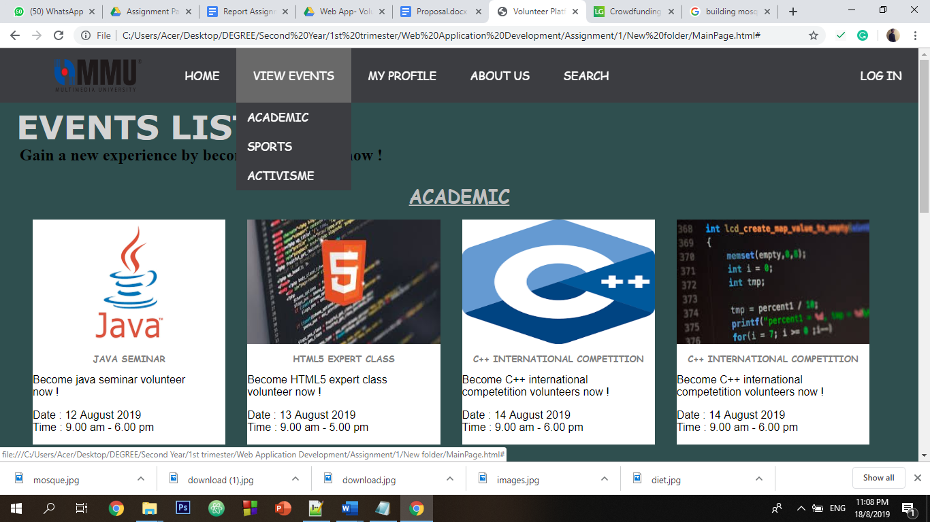

* All of the navigation elements are placed at the center top of the page. The log in and register elements are specifically placed at the top right of the page.
* The important contains of the page, which is the events list is located at the center of the page.
* The details about the developer is located at the footer of the page.

**Navigational Flow**

Hierarchical website navigation (Site Map) :

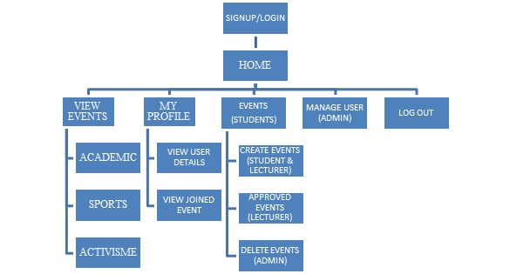

Figure above show the flow of our website based on page level,

* Level 1: Sign Up/Login.
* Level 2: Home
* Level 3: View events, My Profile, Events(Students), Manage User (Admin), Log Out
* Level 3: Academic events, Sports events, Activism events, View user details, view joined event, create new events (Students & Lecturers), approve events (Lecturers), delete events (admin)

**Implementation**

**Navigational bar pop-up**

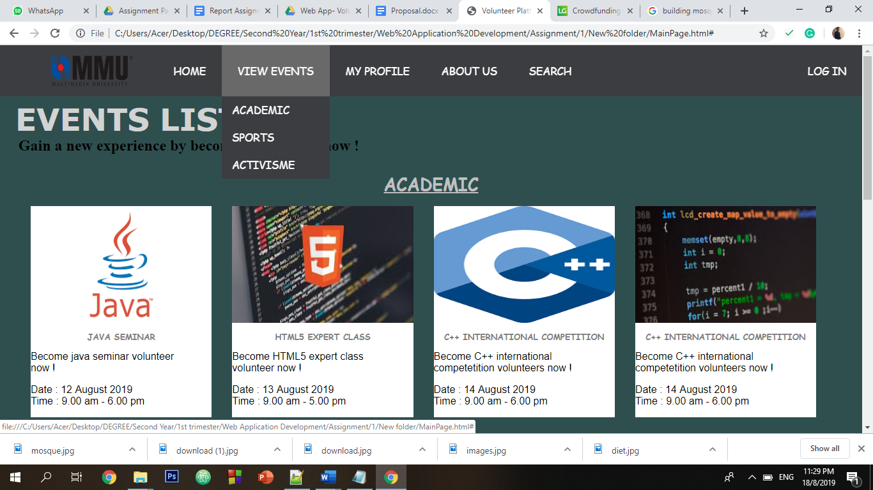

Above image is the navigation bar for student

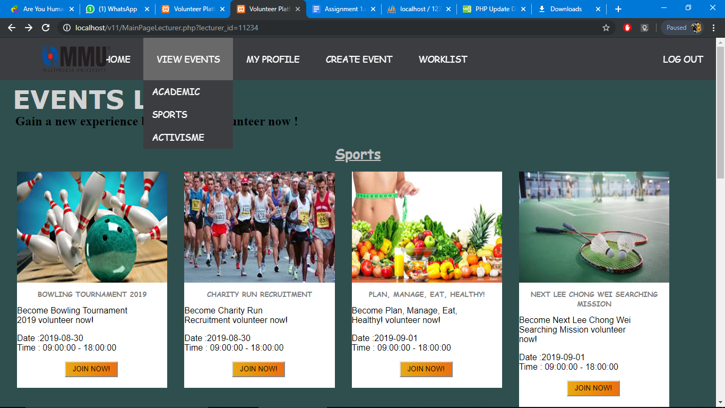

Above is the navigation bar for lecturers

**Event lists pop-up.**

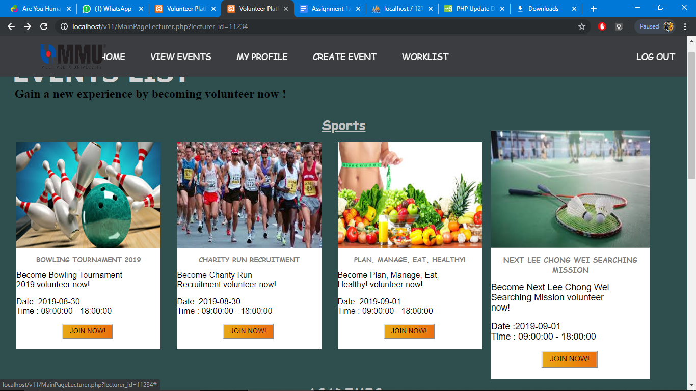

Before hover over second image.

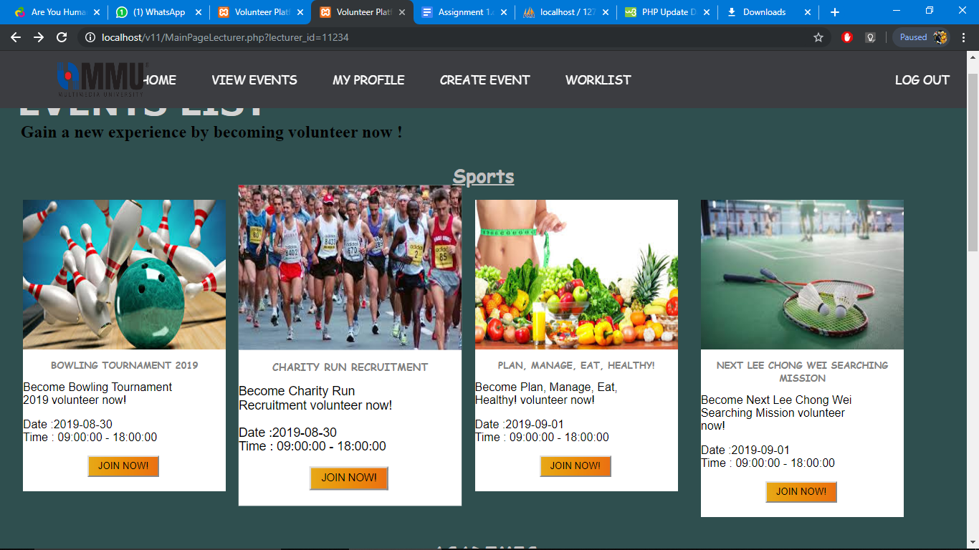

After hover over second image.

**Registration/Log In**

***Log In***

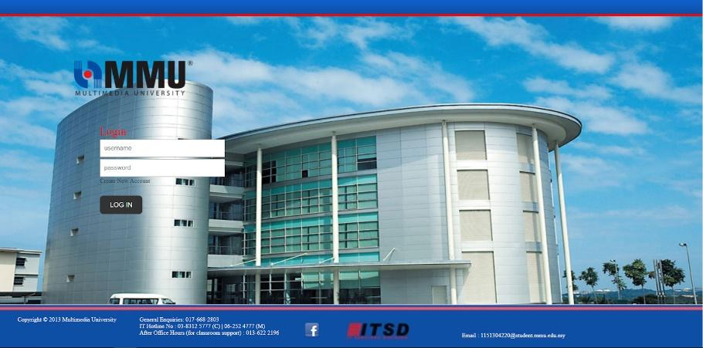

Figure shows the login page, in which the user must enter a valid username and password. As we keened to design a user-friendly user interface. The user can gain more information about copyright and how to contact us from the bottom part.

***Registration***

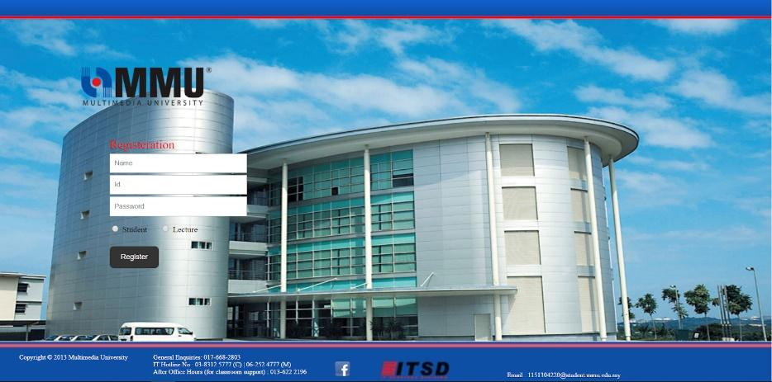

Figure shows the Registration page. In which the user is required to enter a valid name, id and password. The system also required from the user to indicate whether he is registering as student or lecturer. Once the user fills up the required field and press the register button the system will directly conduct a verification process to check form the validity of the registration details. If the result of the verification process was true the data will directly save on the database and the system return pop up message notifying the user about the successful registration, otherwise the system will reject the registration process and a pop-up message will notify the user about process rejection.

**Main Page**

***Student***

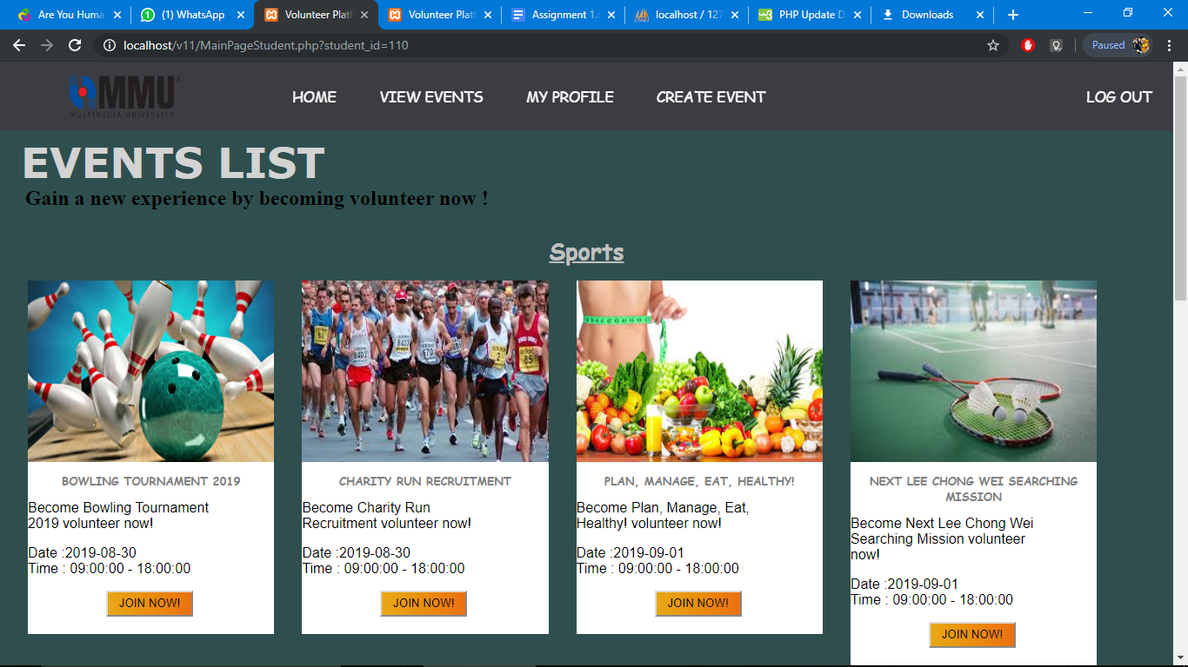

Once the user login successfully, the system will move him directly to the main page. in which the user can gain more information about how our team is work.

The user can use the navigation bar at the top and bottom to move a certain page such as Home, Browse, Search, and other pages, as shown on Figure above

***Lecturer***

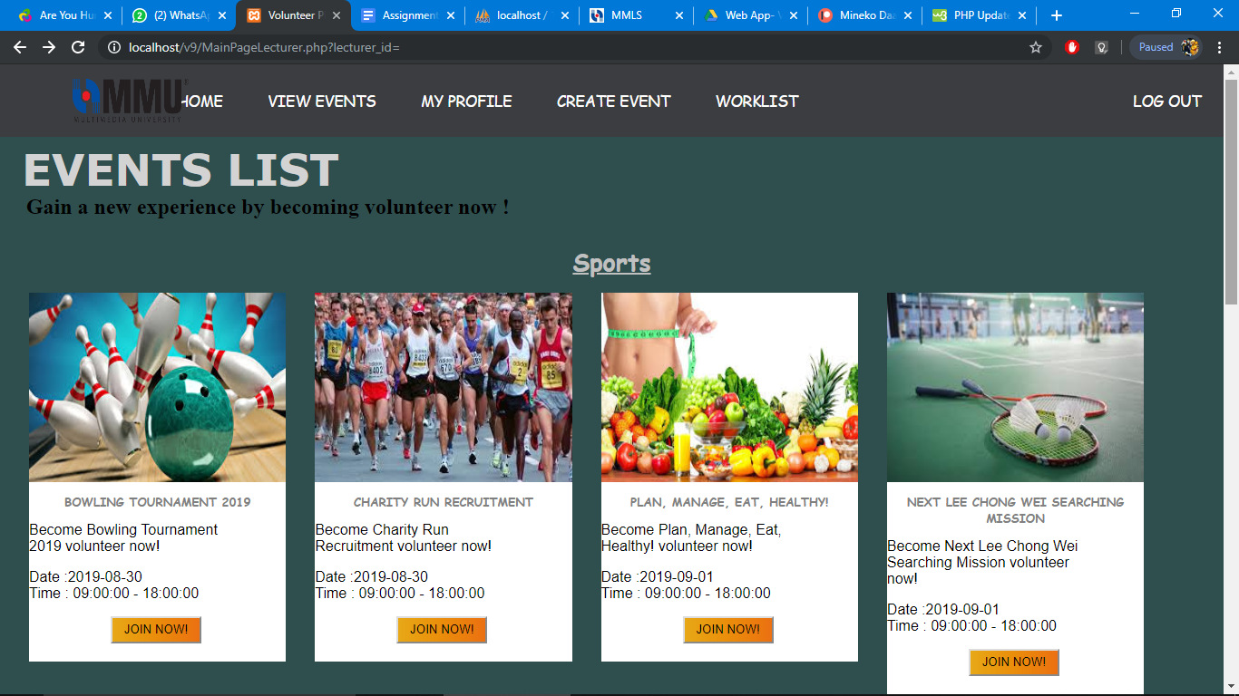

The difference between student and lecturer main page is the navigation bar and the information pass between next pages.

**Students**

***Sign Up Events***

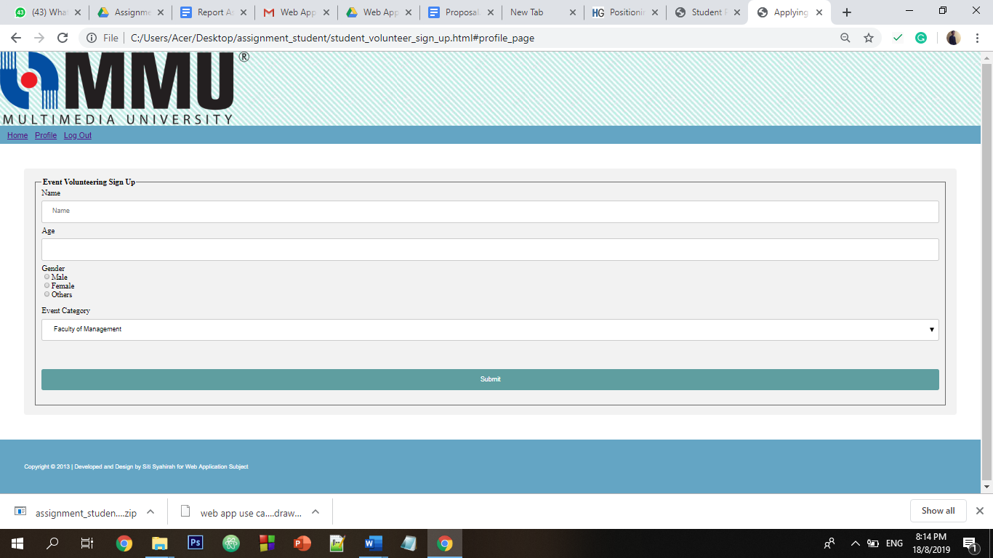

Students can sign up as a volunteer on the desired event. and hence the student information will be saved as a volunteer on the desired event

***Student Request to Add New Event***

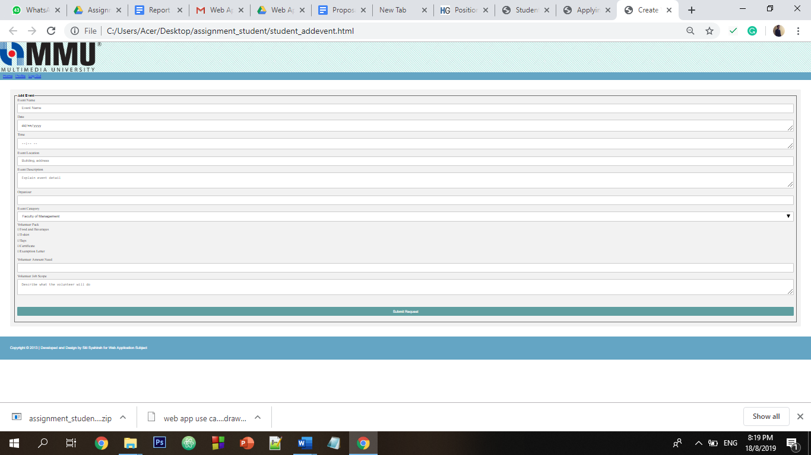

In this feature, the student has the ability to add as many as he wants events that required participating form the others and consider as volunteering activity. All the event request to be add will have pending status and will not be shown on mainpage.

***Student Profile Page***

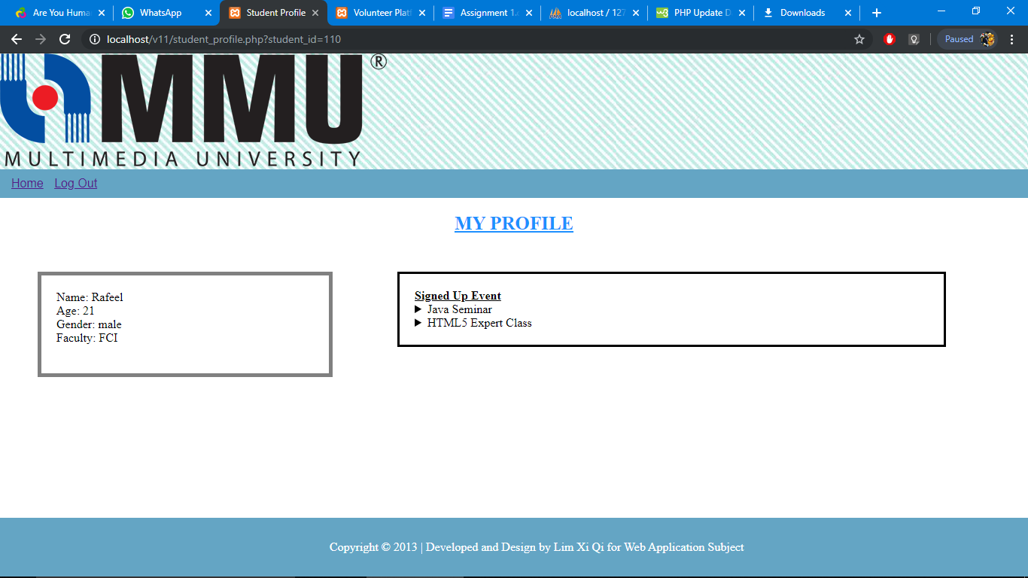Above is student profile page design.

**Lecturer**

***Lecturer Profile Page***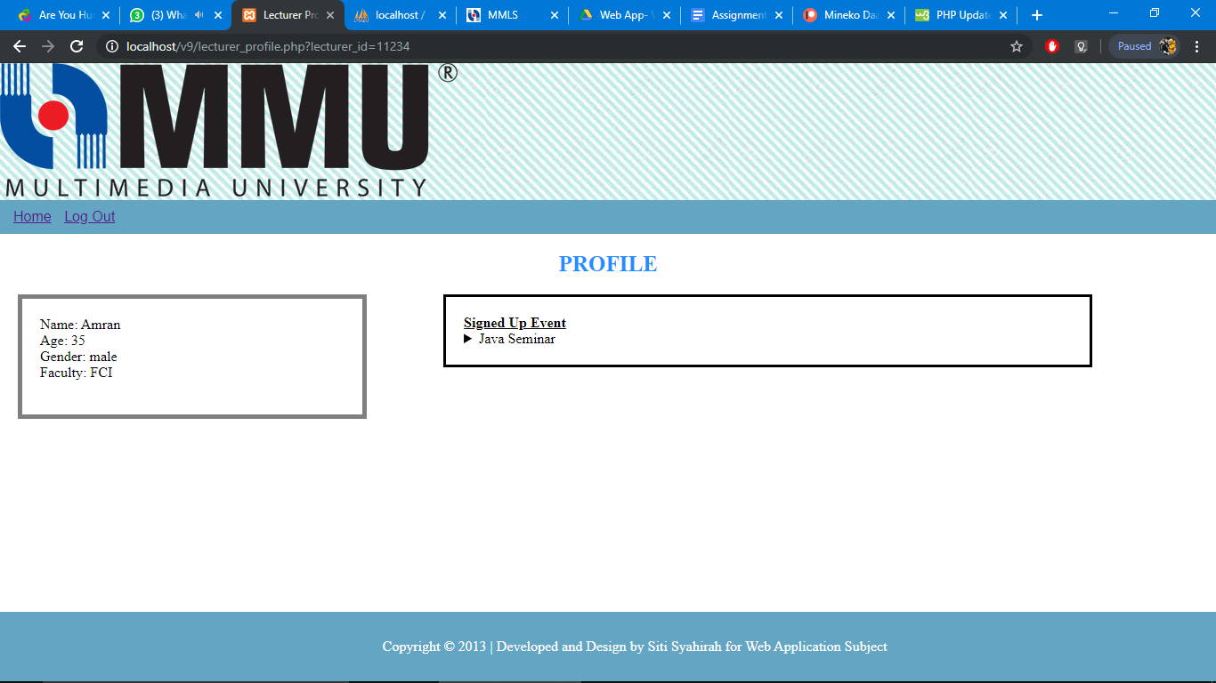

The profile divide into two part. Left side for individual details. And the right side for event joined by the individu. The data extract from database to match the lecturer that log in.

***Lecturer Sign Up Events***

Lecturer sign up to be volunteer page look like above diagram. Once they fill in the form, and click submit, they will be directed to mainpage again. 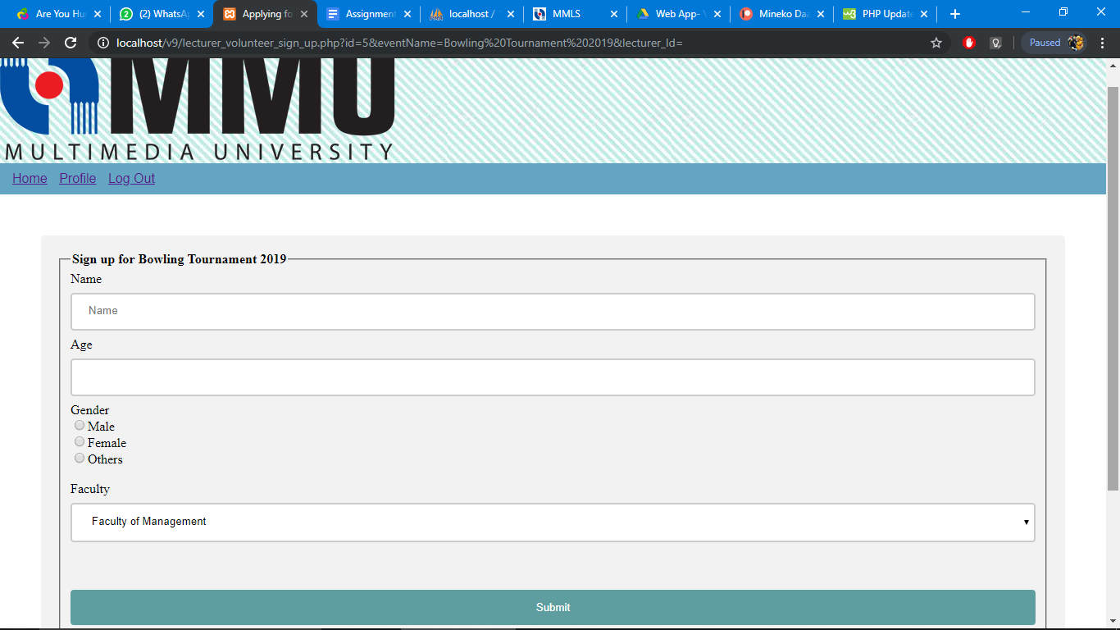

***Lecturer create event***

In this feature, the lecturer also has the ability to add as many as they wants that required participating form the others and consider as volunteering activity. All event add by lecturer will be approved automatically by default. 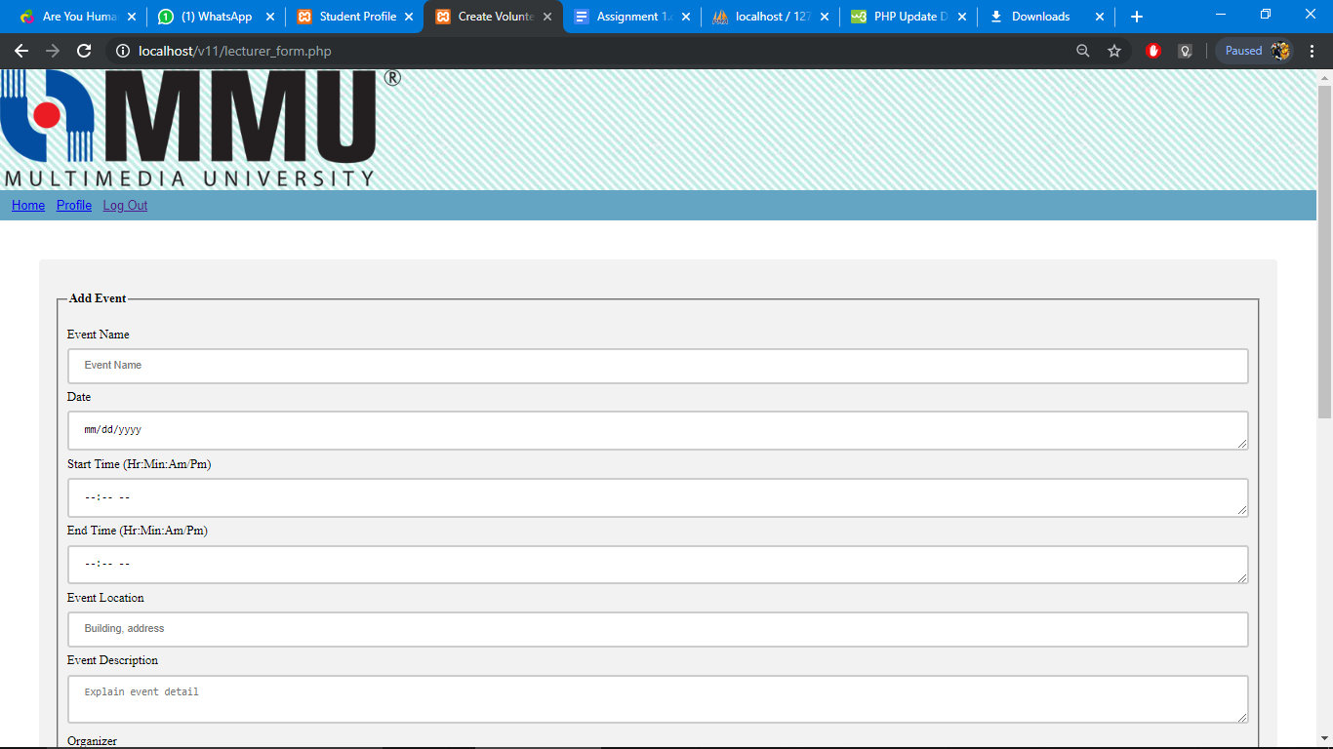

***Lecturer approve event***

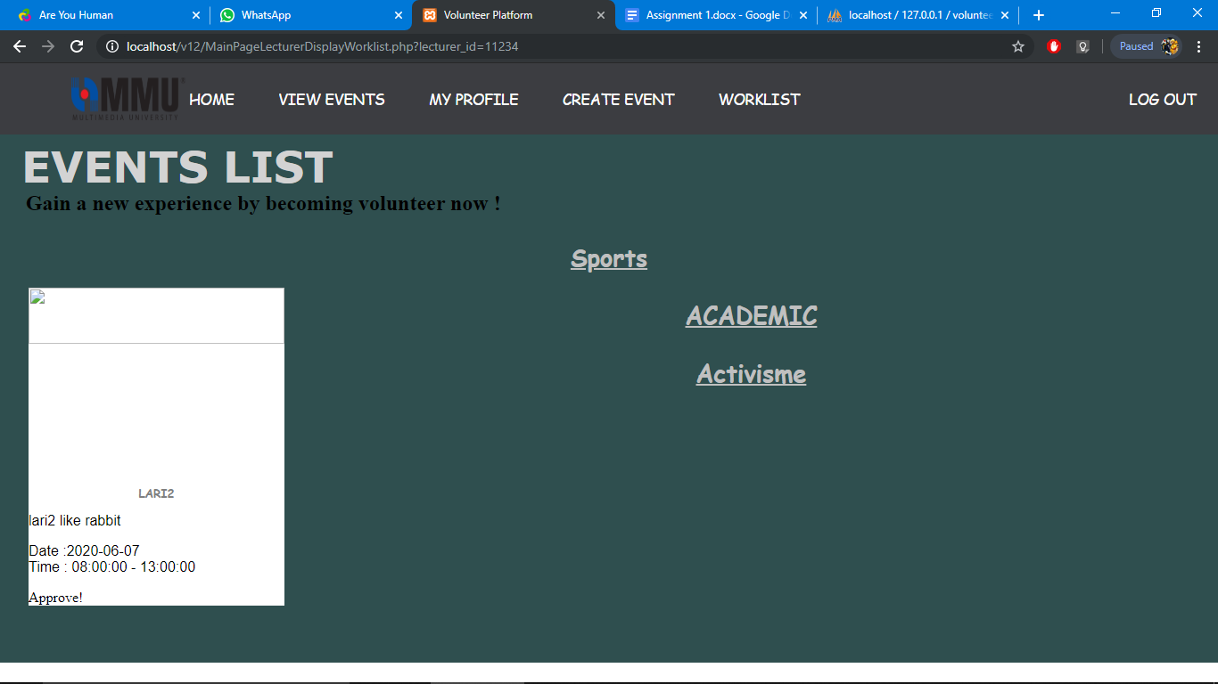Above is the pending event,created by student that will be shown once lecturer click on worklist at the navigation bar.

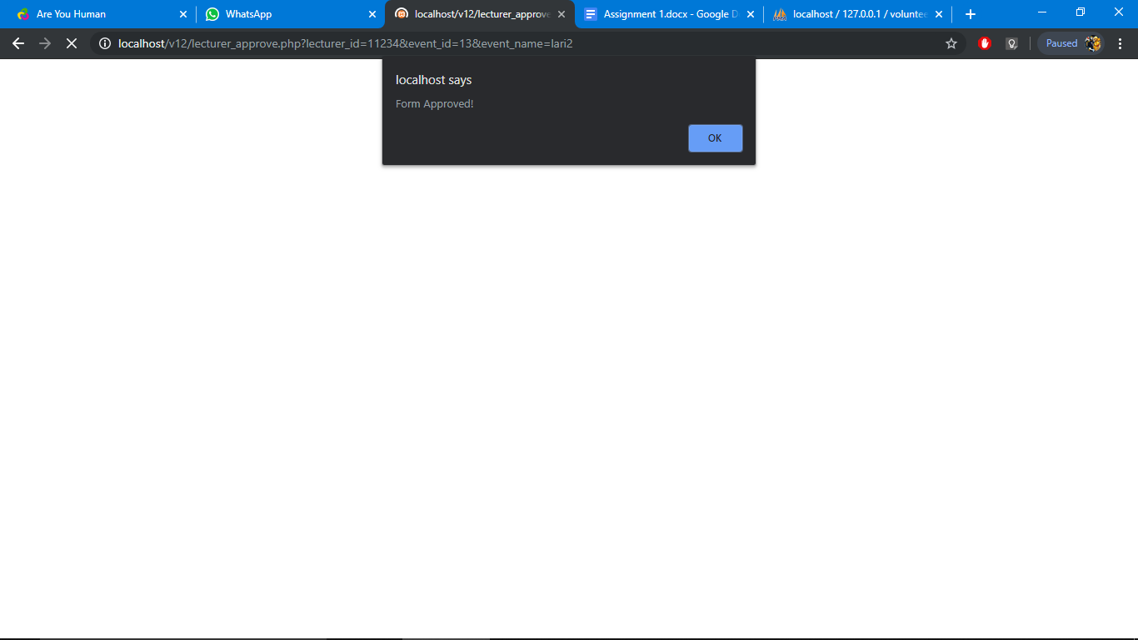

Once the event is click, notification pop up bar will come up to notify the lecturer that the event already approved. Then, lecturer will be guided back to mainpage.

**Admin**

***Admin Home Page***

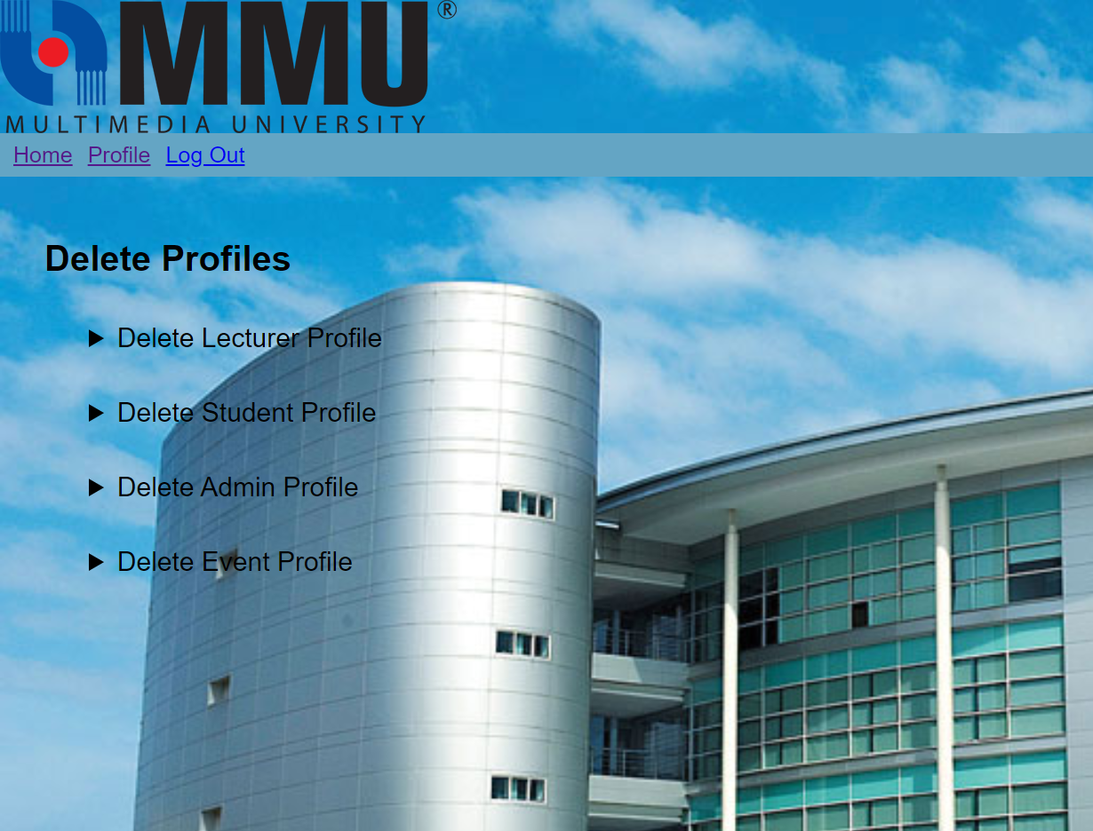

*In this page, the admin will be able to delete the profiles of the users in our volunteering system and events that have been added in the volunteering system.*

***Delete Lecturer Profile***

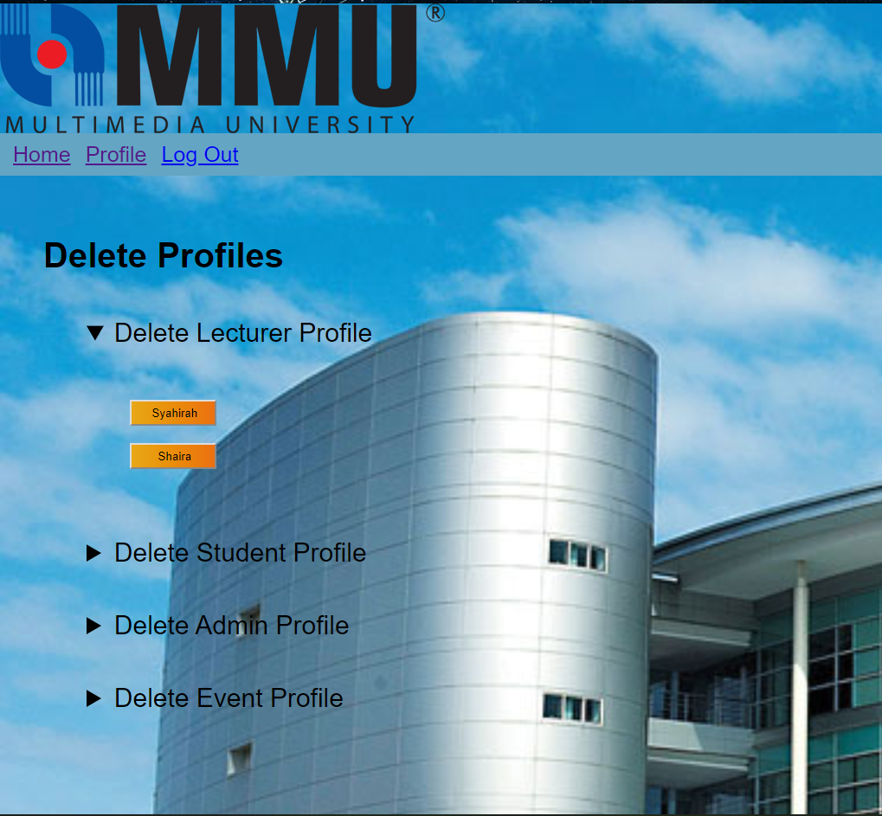

This feature allows the admin to delete the lecturer profile. The registered lecturers’ profile names will display and the admin can choose to delete any one of the lecturers.

***Delete Student Profil*e**

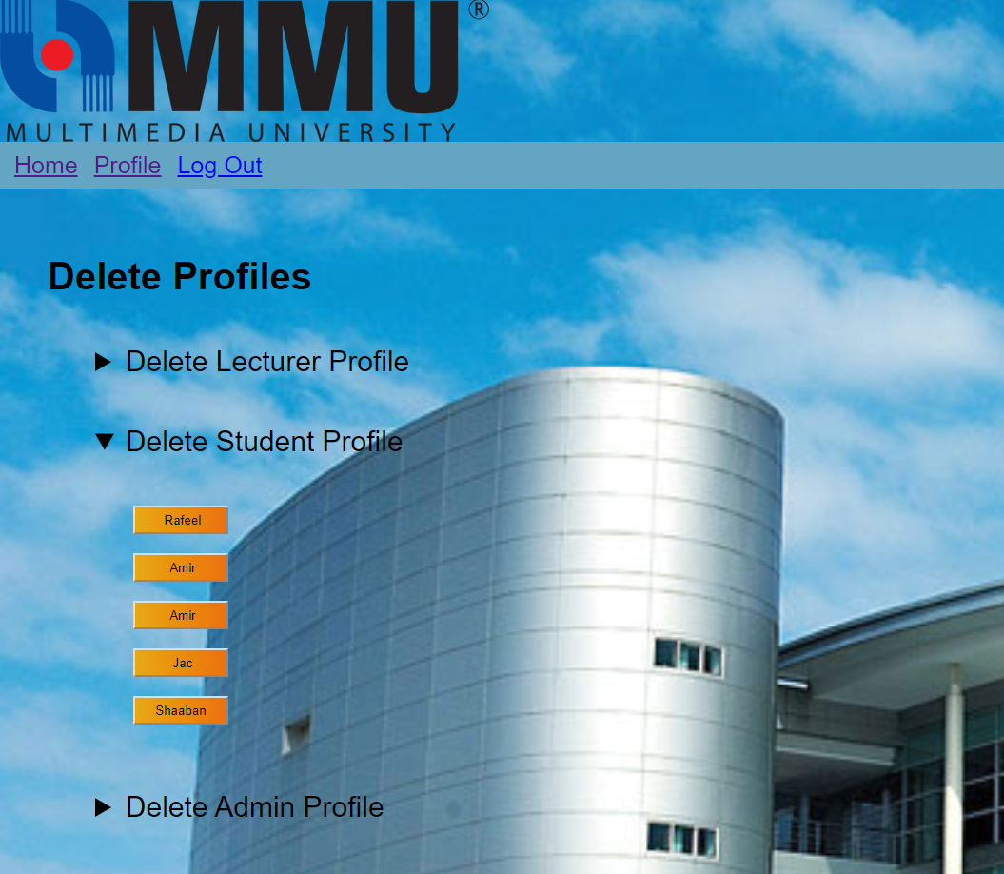

This feature allows the admin to delete student profile. The registered students’ profile names will display and the admin can choose to delete any one of the students.

***Delete Event Profile***

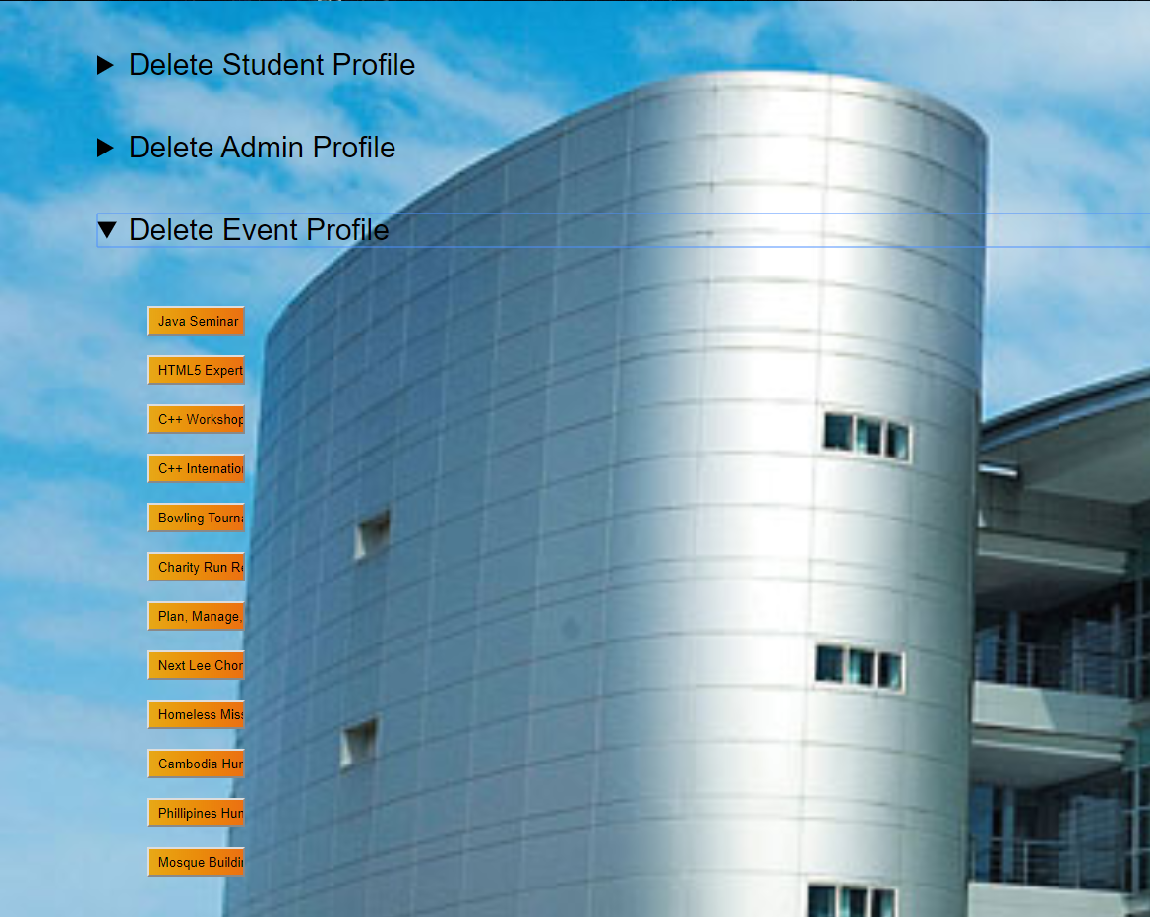

This feature allows the admin to delete event profile. The registered events’ profile names will display and the admin can choose to delete any one of the event*s.*